WATER BILLING SYSTEM

INTRODUCTION

PROBLEM STATEMENT and SOLUTION
Management of resources is the key to development that is holistic and inclusive. With the growing trend of urbabisation, a demand for basic amenities to public is not ignorable. Availability and accessibility of piped water is one of the basic needs of the modern society. Be it metropolitans or small villages, the idea of providing water to all has been one of the basic aims of all the reponsible governments.
The task of providing each house with a piped connection of water is herculean. Equally magnanimous is the task of managing it.
With the rise in number of consumers of the facility, the task of managing the revenue collection and each user’s data is a tedious task.
The water connections in urban areas have now been commercialized with the aim of earning revenue. However, the proper managenemt of such a task has hitherto been done mannually which is obvoiusly prone to errors and goes against the value of tranparency.
Water billing system is a way to ease this problem.

The online water billing system employs the use of internet technology to solve the task and to do it in a more efficient fashion.
- The (Water Billing) system intends to use the internet technology to tackle the basic problem of managing the piped water revenue model.
- The system can generate invoices for individuals as per their usage of water (as indicated by the water meters).
- The Billing system as the name implies, integrates the payment of water bills through online mode.
- The system also stores the water usage data of households and gives them the respective insights about it.
- The online mode of Water Billing System also allows the individual with the option of registering complaints to the authority without physically visiting them.

- The online generation and management of data as well as payment of bills ensures transparency in the system.

The system – very similar to the already being used electricity payment and billing systems – intends to extend the functionality for water as well. Hence, taking a step towards digital economy and also ease of living.
Needless to add, the system also aims at making the whole system more transparent and user friendly.

OBJECTIVES
Since, the billing of electricity connection is already in place and functions smoothly, the Water Billing System on the same line tries to extend this facility for the managemen of water bills as well. In many ways, the system replicates the utilities provided by the aforementioned, which can be broadly listed as follows –
- It primarily aims at digitising the method of invoice generation from the data collected by water meters.
- The system integrates the payment portal as well which allows the customer to pay the bills through online mode of transactions./
- Since the system gathers and works on the data of the users online, it also stores them for future references as well.
- The user can see the pending bills through the portal by using his water meter number/ Consumer number.
- The system inherently creates a transparent system of managing a public resource and the revenue.

- The system also provides for a grievance redressal system by the way of providing the user an option to file his/her complaints.
- The system does not require individual registration from consumer side, rather a centralised repository of water meters and collected data is used.

PLATFORM
While using the sophisticated techinques of management and the simultaneous use of modern technology, the system is incredibly light to use on the user’s machine.
Since the system is completely online, it is platform independent. i.e. can be used in any operating system with a web-browser.
- Platform : Web Based
- Languages :
        - Backend - PHP
        - Frontend - HTML/CSS
        - Browser scripts - Javascript

- Database : MySQL

MODULES
The system to implement its utilities uses the following modules / functions –
1. Login Module
As the name suggests, this module is the gateway to the system. The Login module is where the user is authenticated and taken to his/her respective dashboard.
This is the portal where the users – consumers and the adminstrators are differentiated and autheticated based on the credentials they provide.
This module has been divided into two subparts –
a) Consumer Login
b) Administrator Login
The consumer login portal has been deliberately kept sans-password for the simplicity of use. The consumer enters his consumer number to get access to the required bill and invoice data.
The administrator dashboard is more secured with the use of password and admin ID.
The login module for consumer as well as the administrator draws data from the centralk repository of prestored data.
The data can only be added / modified by administrator level privileges.

2. Bill Generation
This is one of the core modules of thw system. The primary functionality of generating invoices is one by this module.
The module recieves data from the login module (explained above) and further draws respective data from the meter_data database to calculate the total amount based on a predetermined rate.
This module provides the output – the invoice – to the user on his dashboard for his consumer number/ water meter number.
This module can be modified to see data from previous months and determine various usage statistics.
The Bill Generation module further forwards the data to the payment module (explained next).

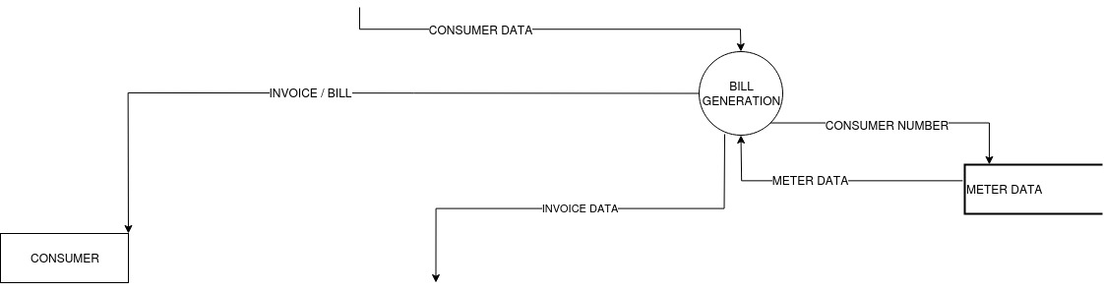
To payment module

3. Payment
The payment module after getting data from the above-mentioned bill generation module opens an option of paymet gateways to the users.
The consumer here can opt any of the payment gateways listed to pay his/her bills.
Major requirement of Payment module is obviouly the SECURITY.
For the conserns of which, this module integrates the system with the payment accepting interfaces of the respective banks.
The module further provides payment reciept (for successful payments) top the payee . It also saves the transaction data to the central database separately.
The failed payments are not recorded by the system and a an error message is displayed.
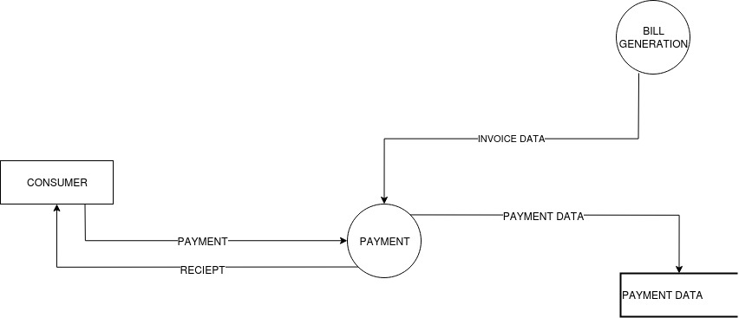

4. Meter Updation
The meter upadation module is a administrator level privilege module – meaning, only administrator can acces the module.
The module basically is a place for updation of meter reading data for the respective consumers.
The adminsitrator gets the meter reading data which is physically collected or is provided by smart meteres.
This module thenn using these data as input maps them to theor respective users and updates the data with the latest data. The upadted data is then used by the bill genertaion module tp generate bills and then for payment.

5. Grievance Redressal (Complaint)
The inclusion of grievance redressal module in the system is aimed at making the whole process more open, easy and user friendly.
The complaints portal has a two way work –
a) It allows the consumer to register complaints to the portal.
b) The administrator can view the complaint and take appropriate actions to redress the grievance.
User is alloted a compalint number and the complaint data is logged in the database. Moreover, the user can add pictures (if needed) in his complaint for the reference.

SYSTEM DESIGN
1. DATA FLOW DIAGRAMS
Data flow Diagram is concerned with designing a sequence of functional transformation that converts system inputs into the required outputs. The design is represented as data flow diagram. These diagrams illustrate how data flow through a sequence of functional transformations.

Data flow diagram is a powerful diagram that can be used to document the information flow. It also presents itself to be broken down in top down fashion .At the top level ,data flow are represented at the very abstract aggregate level .Each component of the data flow is further broken down to different levels, so that at each level. We have just a few entities to concatenate on , DFD have developed a representation scheme to represent data store. Process(where some changes are made to system) and entities(the player in the game) and the actual information flows.

NotationS Used in Data-Flow Diagram:-

Rectangles: represents external entities that interaction with the system. They provide input or receive output.

Arrows: Shows direction of data flow. Their name describe the data flowing
along the path.

One side open box : represents data stores.Again ,theyshould be given a descriptive name.

Circles: represents functions ,which transforms input to output, the transformation name indicates its function.

CONTEXT DFD

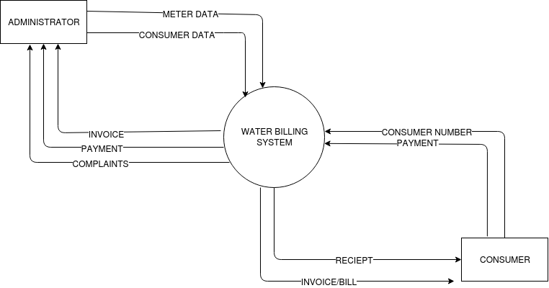

DFD – LEVEL 01

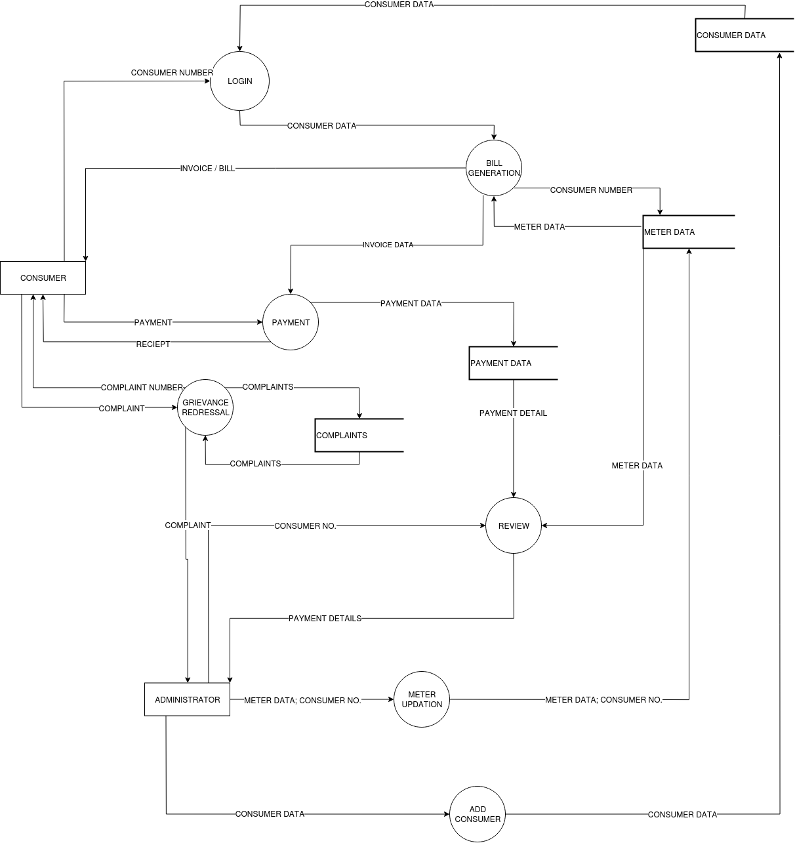

DATA DICTIONARY

Another powerful tool that is extensively used in system analysis in the data dictionary. DDs provides a detailed reference to every data item—the different names by which the item is represented in different program modules, different data structure used to represent the item in different modules. The module where the date item is generated ,where it is stored destroyed .In essence it provides a quick snapshot of every data item is generated ,where it is stored and destroyed .In essence it provides a quick snapshot of every date item is used by the information system. In essence it provides a quick snapshot of every data item used by the information system .It is very useful for consistency checks. System modification and completeness checking.

DATA DICTIONARY

consumer_data = consumer_name + consumer_number + address
consumer_number = alphabet + alphabet + digit + digit + digit
meter_details = meter_number + meter_reading + month_name
payment_details = amount + dateOfPayment + rate + dueDate+ transaction_number
complaint_data = complaint_text + date + complaint_number + + consumer_name
pament_reciept = payment_details + consumer_data + meter_details

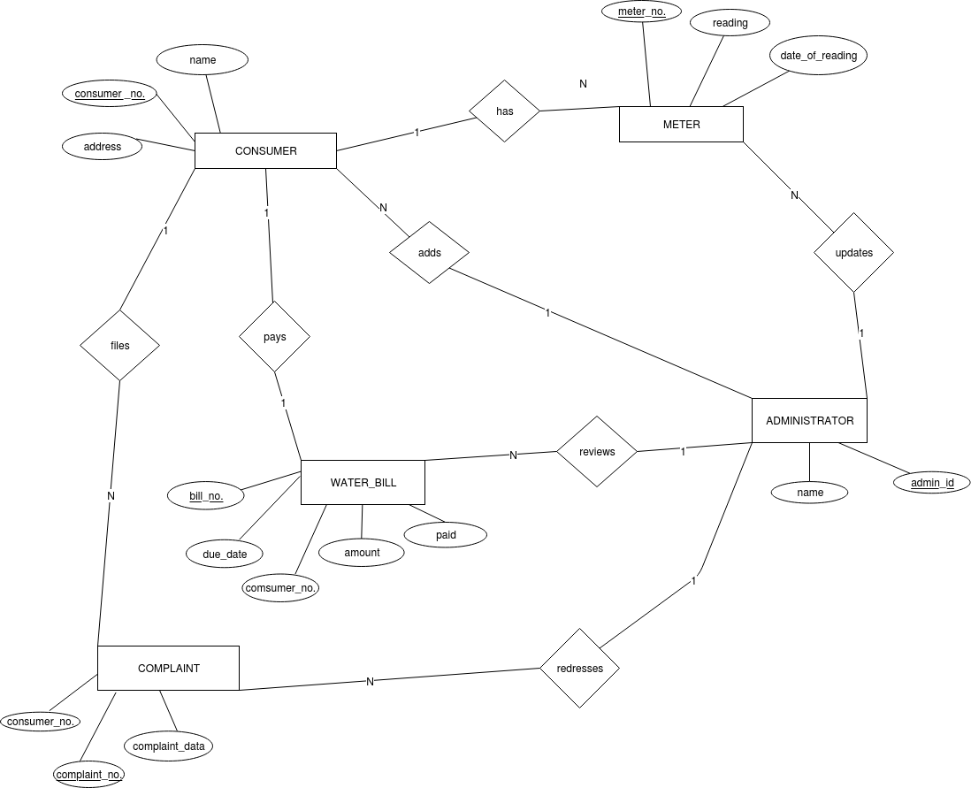
ENTITY RELATIONSHIP DIAGRAM

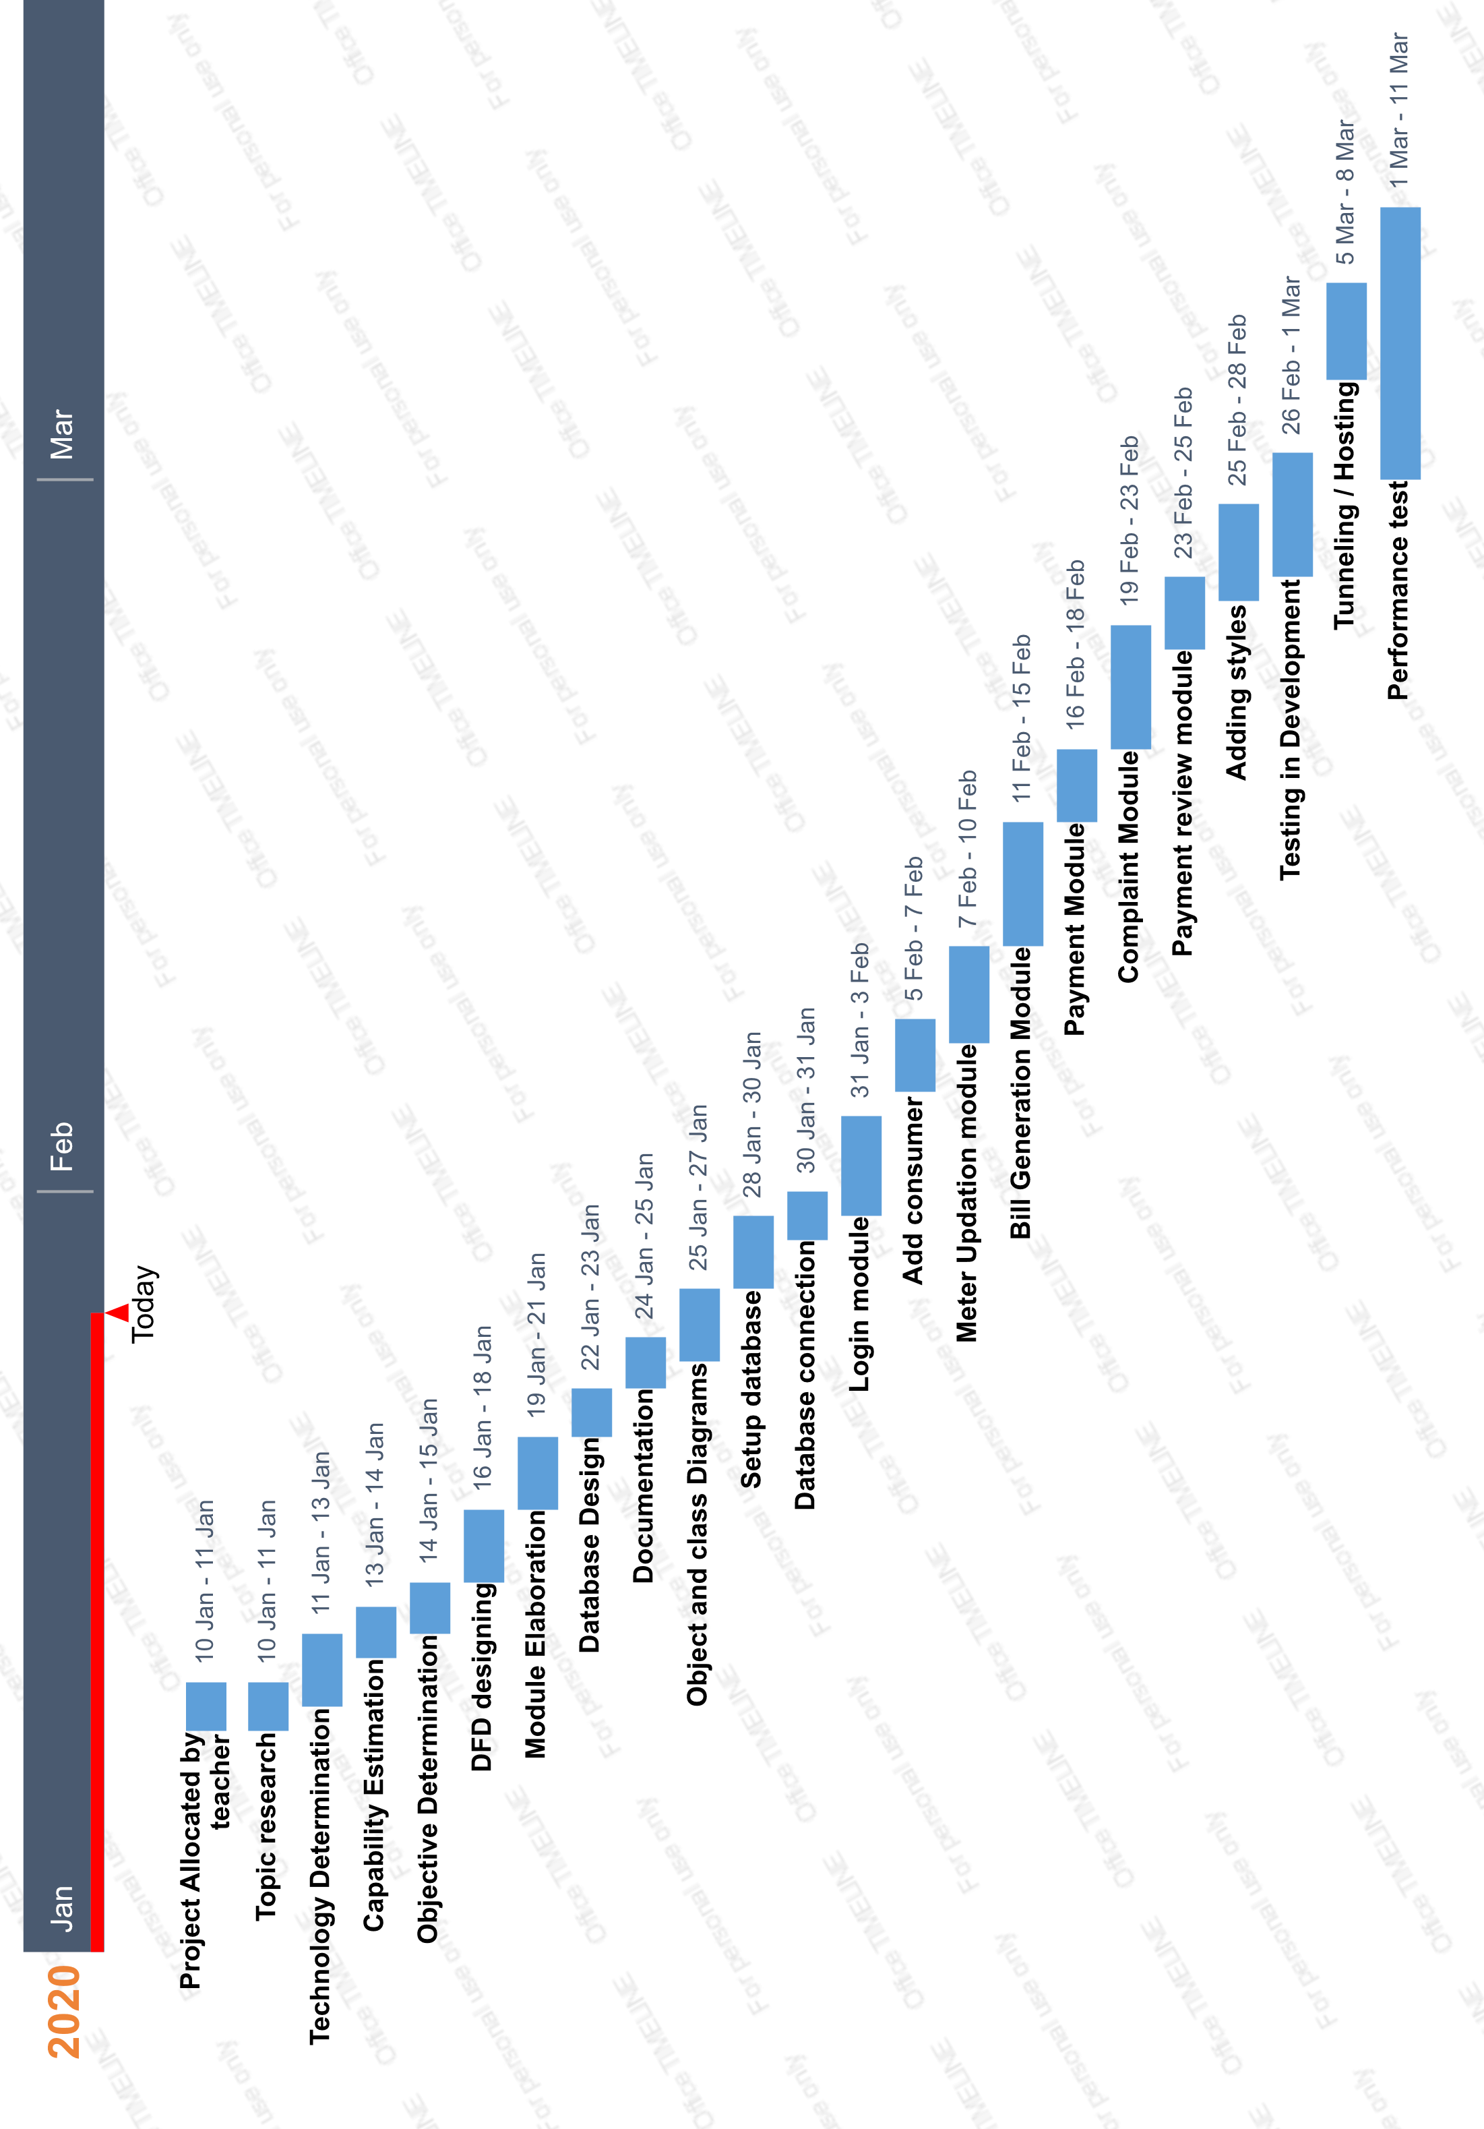
GANTT CHART

OBJECT DIAGRAM

Object is an instance of a particular moment in runtime, including objects and data values. A static UML object diagram is an instance of a class diagram; it shows a snapshot of the detailed state of a system at a point in time, thus an object diagram encompasses objects and their relationships at a point in time. It may be considered a special case of a class diagram or a communication diagram.

Purpose of Object Diagram
The use of object diagrams is fairly limited, mainly to show examples of data structures.
- During the analysis phase of a project, you might create a class diagram to describe the structure of a system and then create a set of object diagrams as test cases to verify the accuracy and completeness of the class diagram.
- Before you create a class diagram, you might create an object diagram to discover facts about specific model elements and their links, or to illustrate specific examples of the classifiers that are required.

Basic Object Diagram Symbols and Notations
Object Names:  - Every object is actually symbolized like a rectangle, that offers the name from the object and its class underlined as well as divided with a colon. | 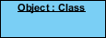
Object Attributes:
- Similar to classes, you are able to list object attributes inside a separate compartment. However, unlike classes, object attributes should have values assigned for them.
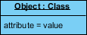

Links:  - Links tend to be instances associated with associations. You can draw a link while using the lines utilized in class diagrams. | 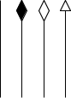

CLASS DIAGRAM

A class diagram in the Unified Modeling Language (UML) is a type of static structure diagram that describes the structure of a system by showing the system's classes, their attributes, operations (or methods), and the relationships among objects.

Purpose of Class Diagrams
- Shows static structure of classifiers in a system
- Diagram provides a basic notation for other structure diagrams prescribed by UML
- Helpful for developers and other team members too
- Business Analysts can use class diagrams to model systems from a business perspective
A UML class diagram is made up of:
- A set of classes and
- A set of relationships between classes

CONCLUSION
After the completion of this project and hosting it for implementation, following may be noted –
- The system undoubtly is more efficient than mannual invoicing and it can be safely said about the system that it can successfully automate a redundant job.
- The saving on the part of mannual labor would be immense in further saving the costs.
- Since the system requires minimal maintenances and is certainly a more effiecient way of performing the given task, it frees the scarce human resource of the redundant and repetative task and thus encourages productive labour of the workforce employed.
- The system brings in transparency in the working of the institution using it and thus it stregthens the trust of the consumers in the institution.

- The major utility provided by the system is the ease and accuracy of getting the work done. Since the complete process of generating the bills of consumers is done by the system internally and automatically, the chance of errors creeping in reduces to minimum.
- The grievance redressal mechanism provided by the system helps in a providing for a responsive service provider and builds faith of the consumer/public in large.

LIMITATIONS

Although the project has been made to suffice for the maximum service providing, it lacks a few things and has the following limitations –
- The system still requires door to door collection of meter data, if the case is of conventional meter and not smart meters which can transfer readings over the internet.
- Centralised database systems have an inherent limitation of data insecurity and demand of regular maintenance and this system too is not an anamoly.
- The lack of password protected login system cretaes a threat of data breach.
- No concrete action can be taken against the non payment of bill within due date. A separate notification and notice to the consumer is needed to be sent.

FUTURE SCOPE
With the growth of affluency and efficiency of public systems, the growth of availibility and demand of such services is a guarantee. Such an online system has the following scopes in future –
- The system can be upscaled to accomodate a huge consumer base.
- With little feature addition, the system can be transformed to an ultimate revenue collector for water and other similar facilities such as natural gas.
- With introduction of government’s Har Ghar Jal Yojana, the usability of the system is bound to increase.
- Few addendums can be made to the system to make it more responsive, like notification and remiders for bill payments.
- The system’s data and build format can be used to later transform it into a blockchain based technology.
- The system can provide users with their monthly water usage data and insights, and can encourage them to save the precious resource.

